**Resume**

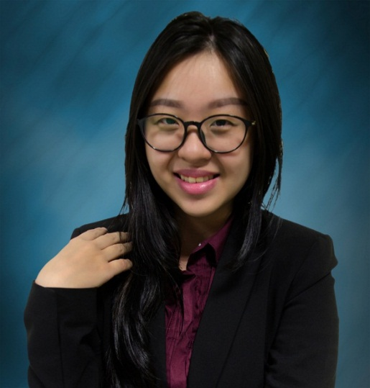

Full Name : LEE LI SHAN ( JOYCE ) 李丽珊

I/C Number : 920311-06-5832

Email Address : joy-ce_lee92@hotmail.com

H/P Number : 012 6672928

Current Address : No. 16 USJ 12/2F SUBANG JAYA

Spoken Language : Mandarin, English , Bahasa Melayu , Cantonese , Hakka.

Current Status : Under taking Bachelor of Finance in Multimedia University Cyberjaya

Available date : 5th June 2017

Working Experience

* Internship in HSBC ( Procurement March 2016 )
* Part timer in See Hoy Chan Holding Group ( 6.3.17-2.4.17 )
* Temporary teacher in primary school (early 2012- mid of 2013 )
* Kumon Part timer in Raub , Pahang branch and Subang Jaya branch
* Event Crew in Loudspeaker ,Soccer Carnival.

Curriculum Experience

|  |  |
| --- | --- |
| **Position** | **Society / Events** |
| Vice President of Internal Affairs | 18th Chinese Language Society |
| Director of Program Division | 17th Chinese Language Society Chinese New Year Extravaganza |
| Special Event Coordinator | 19th Chinese Language Society Famine 30 ( World Vision ) Charity Event |
| Director of Publicity | 18th Chinese Language Society Famine 30 ( World Vision ) Charity Event |
| Assistant Camp Leader | 17th Chinese Language Society Famine 30 ( World Vision ) Charity Event |
| Director of Publicity Division | 11th Chinese Language Society Music Composing Workshop |
| Committee in Program Division | 18th Chinese Language Society Chinese New Year Extravaganza Interaction camp |

* Working Committees and Helpers in Career Fair , MESCORP , Orientation Series Event and training camp by Chinese Language Society.

Personal hobby

1. Travelling
2. Hiking

Strength

1. Initiative
2. Socialize
3. Organizing
4. Planning
5. Punctuality

Area to be improved

1. Explore new things without previous experience
2. Take some time to get used to new environment
3. Only focus one thing in a time

Expected Salary : RM 2,800.00